NM id : F0B3A63ACA4C11A9A484977E05D733D7

Digital Marketing

**Create a Google My Business Profile**

1) LinkedIn Profile URL:

[www.linkedin.com/in/muthumeena-m-ba97a6236](http://www.linkedin.com/in/muthumeena-m-ba97a6236)

2) Facebook Page URL :

https://www.facebook.com/profile.php?id=61550061252295

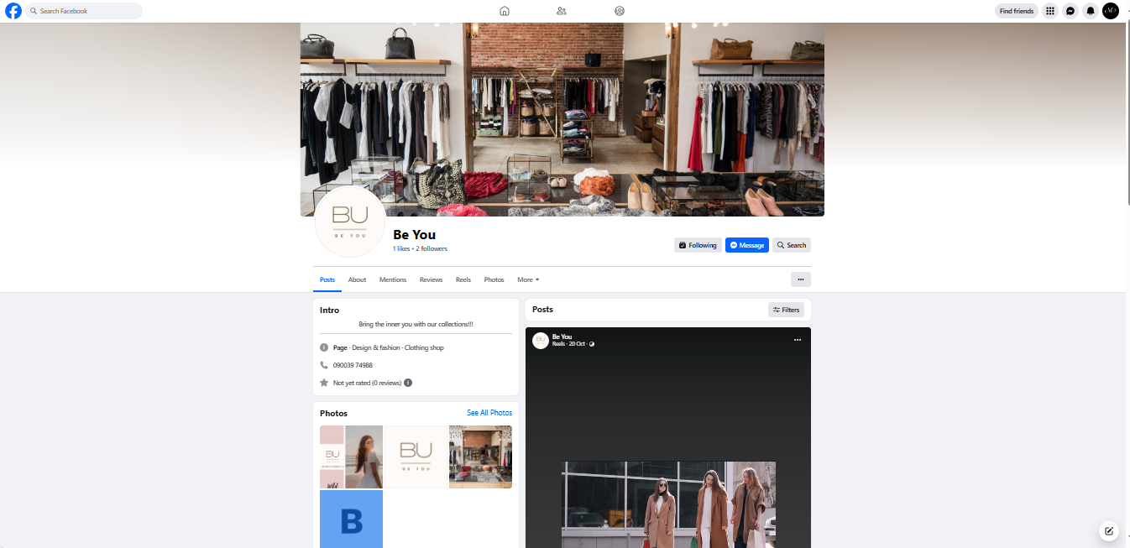

3)Blog or Website URL:

<https://muthumeenabeyou.blogspot.com/2023/09/be-you-blog.html>

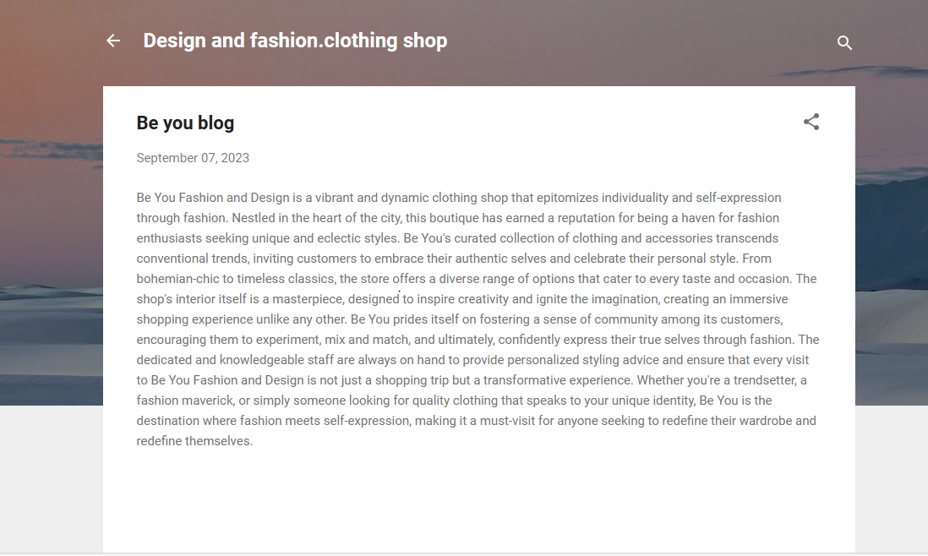

4) Email Newsletter Post - Blog URL:

<https://www.blogger.com/blog/posts/2499998190961399002>

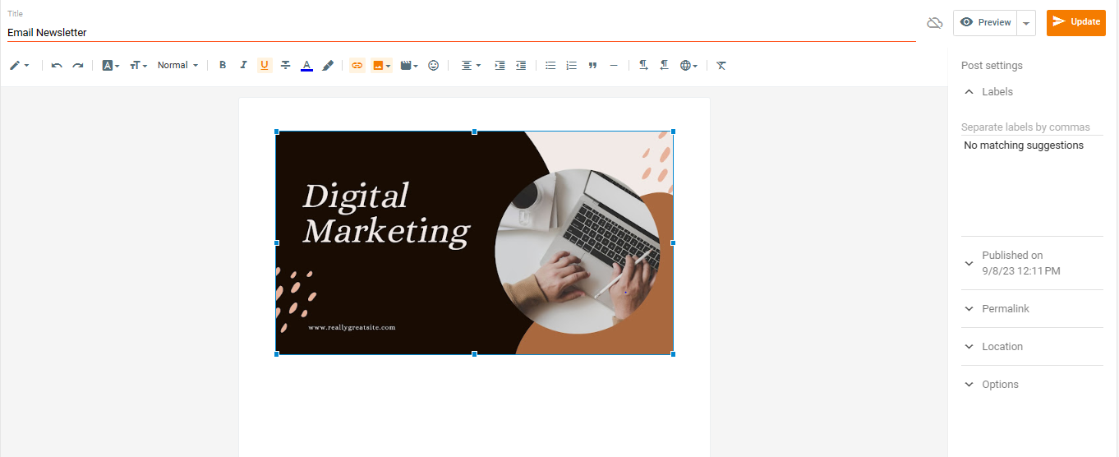

5) Infographic Post - Blog URL:

<https://www.blogger.com/blog/post/edit/2499998190961399002/5134021748684774764>

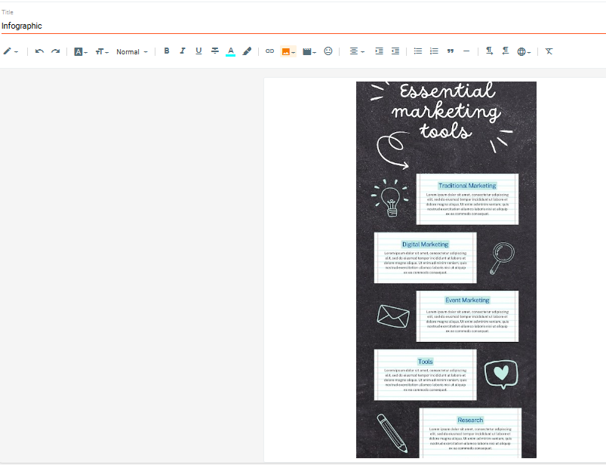

THANKYOU